Cloud Architect

Compute

**Lab Steps**

Task 1: Sign in to AWS Management Console

1. Click on the  button, and you will get redirected to AWS Console in a new browser tab.
2. On the AWS sign-in page,
   * Leave the Account ID as default. Never edit/remove the 12 digit Account ID present in the AWS Console. otherwise, you cannot proceed with the lab.
   * Now copy your **User Name** and **Password** in the Lab Console to the **IAM Username and Password** in AWS Console and click on the **Sign in** button.
3. Once Signed In to the AWS Management Console, Make the default AWS Region as **US East (N. Virginia) us-east-1.**
4. Select Maybe later in New AWS Console Home page pop-up.

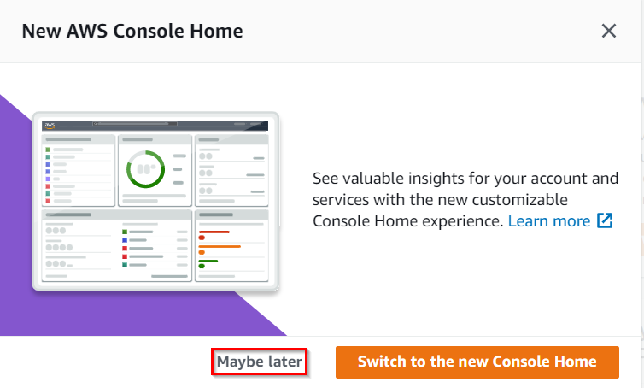

**Note:**If you face any issues, please go through [**FAQs and Troubleshooting for Labs**](https://business.whizlabs.com/labs/support-document/faqs-and-troubleshooting).

Task 2: Create a Security Group for the Load balancer and EC2 Instance

1. Make sure you are in the**N.Virginia**Region.
2. Navigate to**EC2** by clicking on the **Services** menu available under the **Compute**section.
3. On the left panel menu, select the  **Security Groups** under the **Network & Security**section.
4. Click on the **Create security group** button.
5. We are going to create a Security group for the Launch template with port 80 number enabled.
   * Security group name: Enter ***ALB-EC2-SG***
   * Description: Enter ***Security group for the load balancer and EC2 Instance***
   * VPC: Select **Default VPC**

* Click on the **Add rule** button under **Inbound rules.**
  + Type : Select **HTTP**
  + Source: Select **Anywhere- IPv4**
  + **Note:**SSH port is not required.

1. Leave everything as default and click on the **Create security group**button.

Task 3: Launch EC2 Instances

1. Make sure you are in the **US East (N. Virginia) us-east-1** Region.
2. Navigate to **EC2**by clicking on the **Services** menu in the top left, then click on **EC2** in the **Compute** section
3. Navigate to**Instances**on the left panel and click on **Launch Instances.**
4. Navigate to **Instances** from the left side menu and click on 
5. Under the **Name and tags** section :

Name : ***Whiz-instance***

In Summary provide **2** instances.

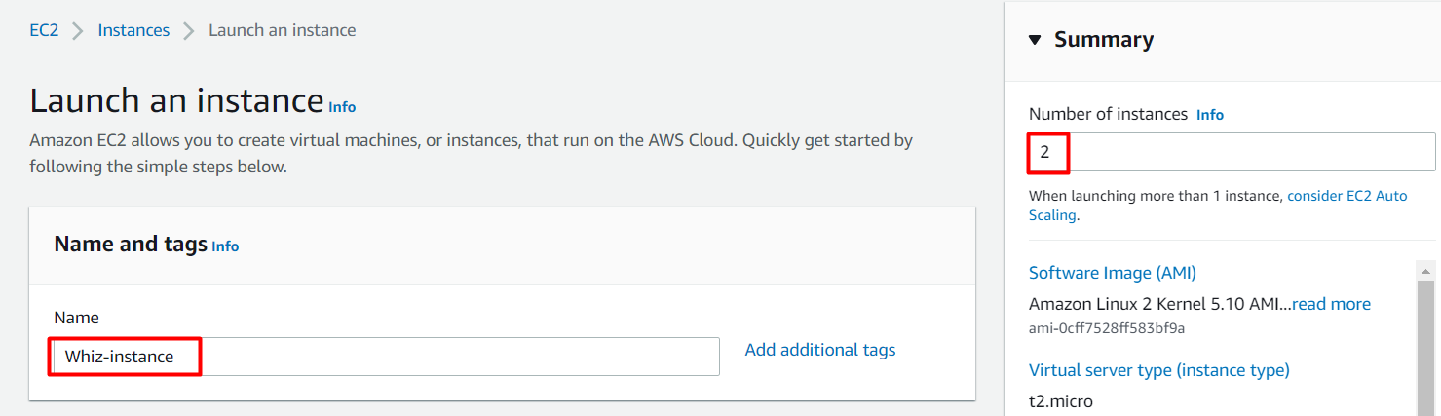

1. Under the **Application and OS Images (Amazon Machine Image)** section :
2. Select **Quick Start** tab and **Amazon Linux** under it
3. Amazon Machine Image (AMI) : select *Amazon Linux 2 AMI*

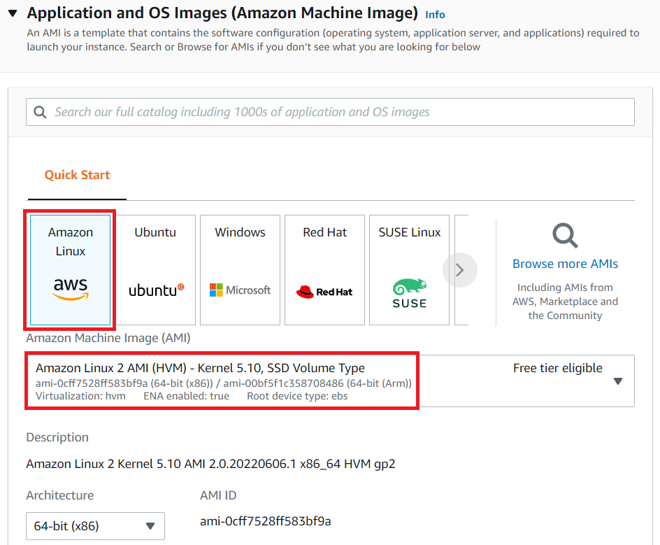

**Note: if there are two AMI's present for Amazon Linux 2 AMI, choose any of them.**

1. Under the **Instance Type**section **:**
   * Instance Type : Select **t2.micro**
   * 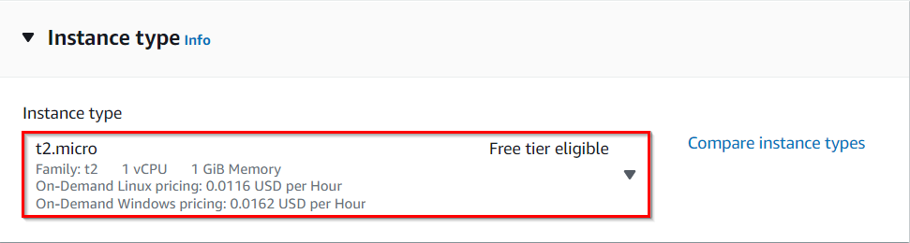
2. Under the **Key Pair (login)**section **:**
3. No need to generate keypair, you have to proceed without a KeyPair.
4. Under the **Network Settings**section **:**

* Click on **Edit** button
* Leave the default VPC as it is.
* Under subnets select us-east-1a.
* Auto-assign public IP: select ***Enable***
* Firewall (security groups) : Select **Select existing security group**
* Common security groups : Select Security group with name**ALB-EC2-SG**

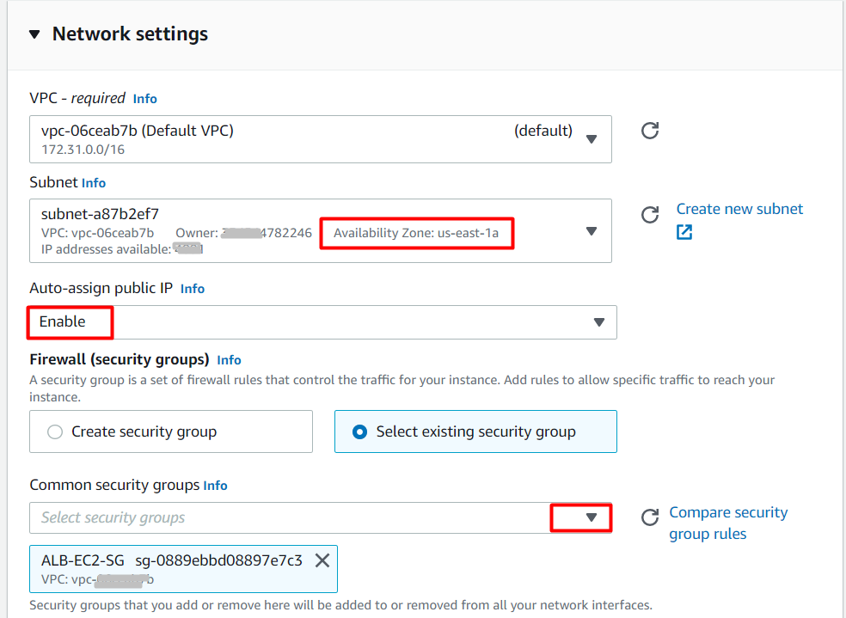

1. Expand  **Advanced Details**and under the **User data:** section, enter the following script to create an HTML page served by an Apache httpd web server.

#!/bin/bash

sudo su

yum update -y

yum install httpd -y

echo "Hello World from $(hostname -f)" > /var/www/html/index.html

systemctl start httpd

systemctl enable http

1. Keep everything else as default and click on the **Launch instance** button.
2. You will be ask for keypair, Select Proceed without Keypair. And click on **Proceed without Keypair** Button.
3. Click on **Launch Instance**.
4. **Launch Status:** Your instance is now launching, Navigate to **Instances** page from the left menu and wait until the status of the EC2 Instance changes to **running**.

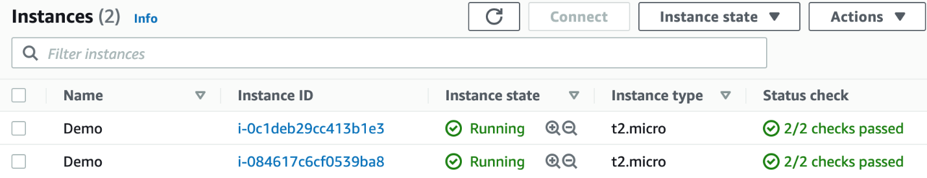

Task 4: Create target groups and application load balancer

1. In the **EC2** Console, Navigate to **Target Groups**, present in the left panel under **Load Balancing**.
2. Click on the **Create target group** button.
3. For **Step 1, Specify group details**
   * **Under Basic configurations**
     + Choose a target group:  Choose **Instances**
     + Target group name:  Enter ***EC2-TG***
   * **Keep all the settings as default.**
   * Scroll to the end of the page and click on the **Next** button.
4. For **Step 2, Register targets**
   * Select **both** the EC2 Instances and click on **Include as pending below**button
   * Click on the **Create target group** button.
5. **The Target group is now created.**
6. In the EC2 console, navigate to **Load Balancers** in the left-side panel.
7. Click on at the top-left to create a new load balancer for our web servers.
8. **Select Load Balancer Type**: Under the **Application Load Balancer**, click on**Create**Button.
9. To create an Application load balancer, **configuring the load balancer** as below
   * For the **Basic configuration** section,
     + Name: Enter **Web-server-LB**
     + Scheme: Select**Internet-facing**
     + IP address type: Choose **IPv4**
   * For the **Network mapping** section:
     + VPC: Select **Default**
     + Mappings:Choose **us-east-1a** and**us-east-1b**
     + **Note:** we must specify the availability zones in which the load balancer needs to be enabled, making route traffic only to targets launched in those availability zones. You must include subnets from a minimum of two Availability zones to make our Load balancer Highly-Available.
   * For the Security groups section, Select the **ALB-EC2-SG Security group** from the dropdown and **remove the default security group**.
   * For the **Listeners and routing** section,
   * The first listener is already present with Protocol HTTP and Port 80.
   * **Select the target group EC2-TG for the Default action forwards to option.**
10. Keep the tags as default and click on the **Create load balancer** button in the bottom right corner.
11. **You** **have successfully created the Application Load balancer.**Click on the**View load balancers button.**
12. Wait for 2 to 3 minutes for the load balancer to become **Active**.

Task 5: Enable stickiness by modifying the Target Group attribute

1. In the **EC2** Console, Navigate to **Target Groups**, present in the left panel under **Load Balancing**.
2. Click on the name of the Target group created.
3. In the Targets tab, make sure the status is Healthy for both instances.
4. Now switch to the Attributes tab and click on the**Edit**button.  
   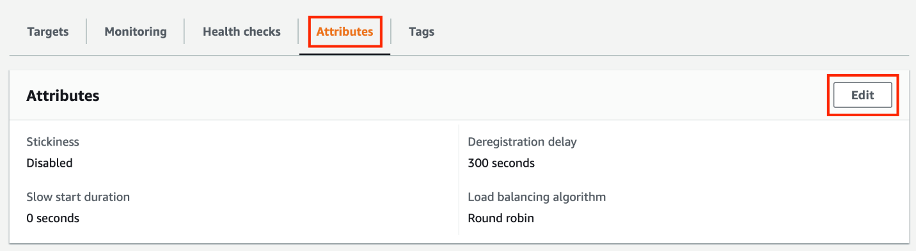
5. On the Edit attributes page, **Check the option** of Stickiness.
6. Keep the stickiness type as Load balancer generated cookie and update the stickiness duration to 2 minutes.  
   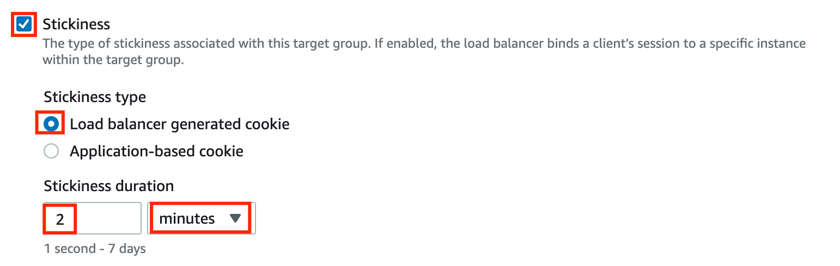
7. Once done, click on the **Save changes**button.

Task 6: Testing the stickiness

1. In the EC2 console, navigate to **Load Balancers**  in the left-side panel.
2. Select the Load balancer present and copy the DNS name of your load balancer, and paste it into the browser.
3. The load balancer will stick to an instance for the duration of 2 minutes, keep refreshing and the instance will not change.
4. After 2 minutes, it should be redirected to a new page.  
   

Task 7: Delete AWS Resources

Terminating EC2 Instanes:

1. In the EC2 console, navigate to **Instances.**
2. To terminate both instances at once, follow the steps presented below.
   * **Select** both the Instances,
   * Click on the **Instance state** option present in the menu,
   * Choose the option of **Terminate instances**,
   * In the pop-up menu, click on the **Terminate** button.
3. Instances will be terminated in a few minutes.

Delete Load balancer

1. In the EC2 console, navigate to **Load Balancers** in the left-side panel.
2. **Web-server-LB** will be listed here.  
   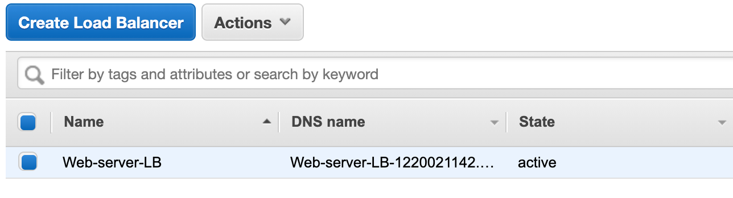
3. To **delete** the load balancer, need to perform the following actions:
   * **Select** the load balancer,
   * Click on the **Actions** button,
   * select the **Delete** option.  
     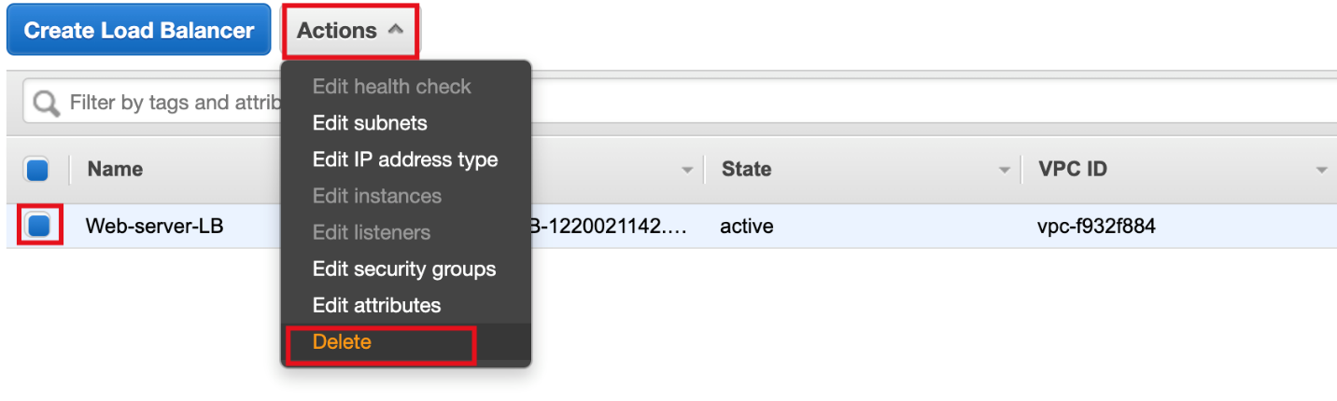
4. Confirm by clicking on the **Yes, Delete** button when a pop-up is shown.  
   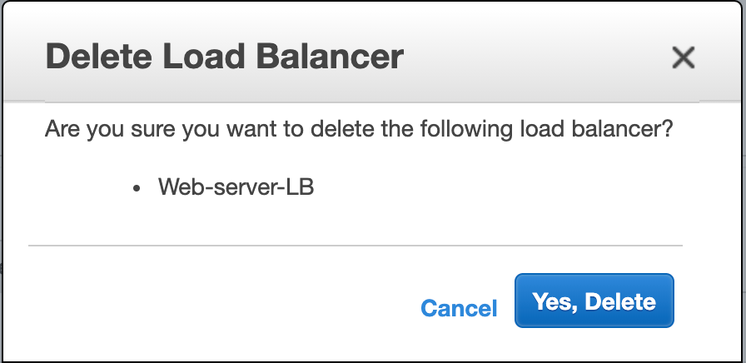
5. MyNetwork-LB will be deleted immediately.

Delete Target group

1. In the EC2 console, navigate to **Target Groups** in the left-side panel.
2. **EC2-TG** will be listed here.
3. To **delete** the target group, need to perform the following actions:
   * **Select** the target group,
   * Click on the **Actions** button,
   * select the **Delete** option.
4. Confirm by clicking on the **Yes, Delete** button when a pop-up is shown.
5. The target group will be deleted immediately.

**Completion and Conclusion**

1. You have successfully created a security group for EC2 and Load balancer
2. You have successfully launched 2 EC2 Instances.
3. You have successfully created a target group and Application load balancer.
4. You have successfully enabled the stickiness and tested using the load balancer DNS name.

**End Lab**

1. Sign out of AWS Account.
2. You have successfully completed the lab.
3. Once you have completed the steps, click on  from your whizlabs lab console and wait till the process gets completed.

1h 29m 40s left

End Lab[Open Console](https://576360660901.signin.aws.amazon.com/console?region=us-east-1)

Lab Credentials

User Name



Password



Access Key



Secret Key



Support Documents

Need help?

* [How to use Hands on Lab](https://business.whizlabs.com/labs/support-document/labs-instructions-and-guidelines)
* [Troubleshooting Lab](https://business.whizlabs.com/labs/support-document/lab-troubleshooting-need-help)
* [FAQs](https://business.whizlabs.com/labs/faqs-labs-general)